Linked list

1. Write a python program to implement linked list and perform the following operations
2. Insertion
3. Deletion
4. Search
5. Print

Graph

1. Write a python program to create a graph and print the adjacency list.
2. Write a python program to traverse the following graph using BFS algorithm

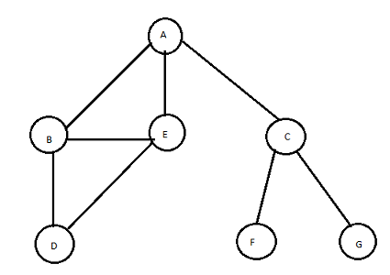

Tree

1. Write a python program to perform the following tree traversals
2. Preorder
3. Postorder
4. Inorder
5. Write a python program generate minimum spanning tree from following weighted graph

